

“How To…” X3V6 Guide

Web Service Orders

Introduction
This document outlines the process required to create sales orders through an X3V6 web service. These instructions are meant to be used with activity code XA41. There are several documents that the user may want to review or have on-hand when initially processing an order through a web service to X3. Those documents include the following:
- Sage X3 Web Services – This is a powerpoint training guide with significant narrative to explain the setup of web services and using the Web Server/WebService tester for processing transactions into X3. Also, introductions to using the Axis server to retrieve samples of DotNet™ and Java™ integration with the X3 SOAP web services
- INS-XA41_WebServices – This document explains the installation of the XA41 patch. This patch provides the web services available with activity code XA41. It also explains the functional setup of the parameters required to run the web services. (Technical setup is addressed through the X3 console - ref. Web Server/Web Services.)
- X3V6_webservices – This document contains examples of how to access each of the individual web services as well as definitions of the fields available through the web services.

A way of thinking about a web service order is to consider it another type of interface into the X3 sales order system. In other words, there are many approaches to processing data into X3. There is an X3 client that uses X3 objects to get and retrieve data, there is an Internet Browser version that uses html and ActiveX™ procedures to process data into and out of X3, there is a flat file interface that can be used to load orders into X3. In a similar manner, a web service is another type of interface using SOAP (Simple Object Access Protocol) to connect to X3.

The advantage of SOAP is that it is an open standard that is used as a common web service approach by many websites. The message is constructed using XML, the transport is HTTP and the valid methods and envelope are defined in a WSDL. For example, a message may be sent to “CREATE” an order along with the data necessary to accomplish this., ie, customer number, products purchased, etc.

Setting Up to Process a Sales Order through a Web Service

X3 License – Development > Utilities > Verifications > License Inquiry
The license inquiry shows the available options that can be executed through the X3 applications. Notice, the web services section circled below. This value indicates the number of concurrent web services that may be executing in an X3 Runtime. The value must be non-zero to run a web service connection.

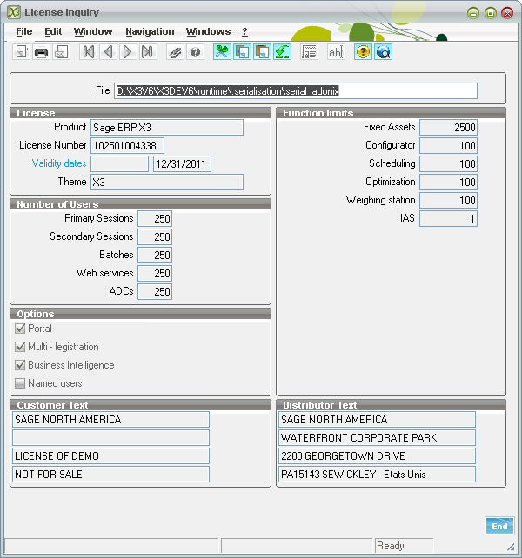

X3 Console – Web Server/Web Services
The next step is to configure the web service connection in the console.
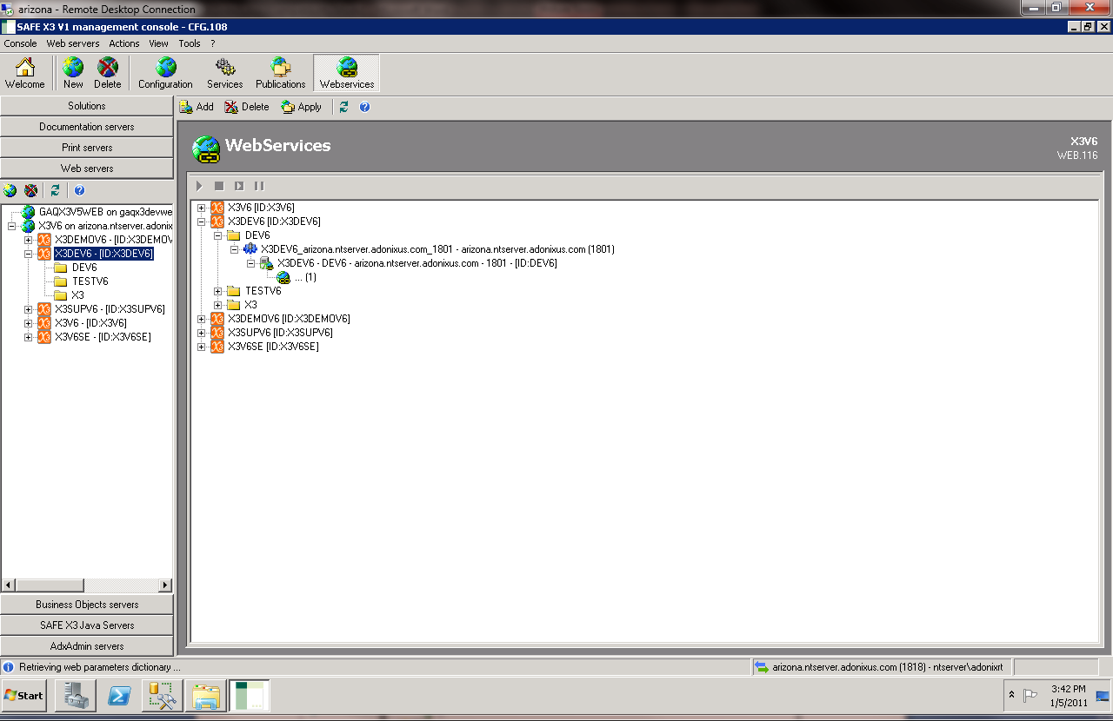

X3 Console –Web Services Pool Configuration

Select or define a pool. A pool is a collection of connections into X3 as limited by the license. For example, there can be 1 pool that supports 5 concurrent connections into X3. The length of the outstanding requests to a pool is managed by minimizing the length of the queue against any one of the connection streams. (I.e., if there are 5 connections in the pool and 10 outstanding requests, the length of the queue to any one of the connections is 2.)

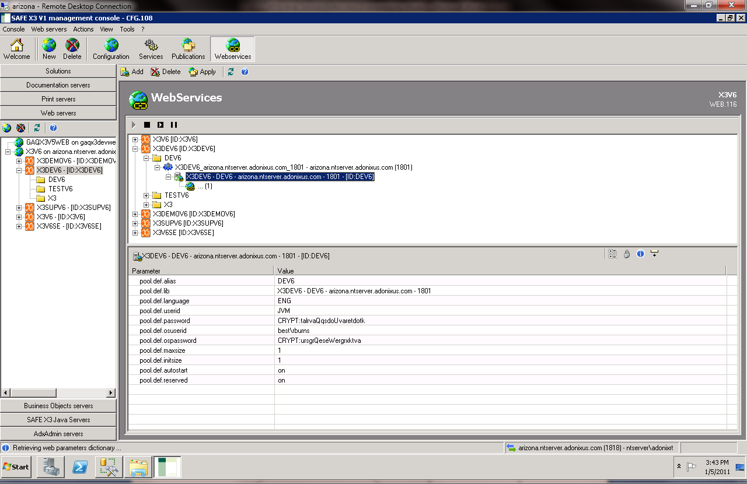
Pool information must be defined for the web service in addition to having a license
(See Sage X3 Web Services document for more information on defining the parameters in the pool.)

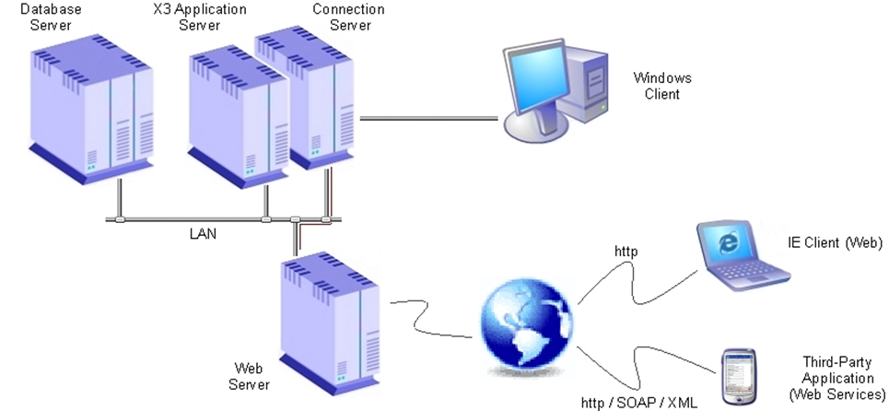
Figure 1: X3 Application Architecture with Web Server

In the above figure, the web server is an Apache/Tomcat™ server. The Tomcat integration supports the web service interface. Following the ‘green’ lines indicates the portion of this architecture we are concerned with in web services.

The interface to the web service will be located on the web server, normally identified at url
http://localhost:28880
where localhost is referring to the web server. A username/password will be required to access the tomcat server. Note, this interface to Tomcat is supported by IEv7 or later. The reason is that the interface uses ActiveX objects. This applies only to the tomcat user interface graphical user and not the web service interface.

Testing the web service
After connecting to the URL and signing into Tomcat, the user will see a page similar to the following:

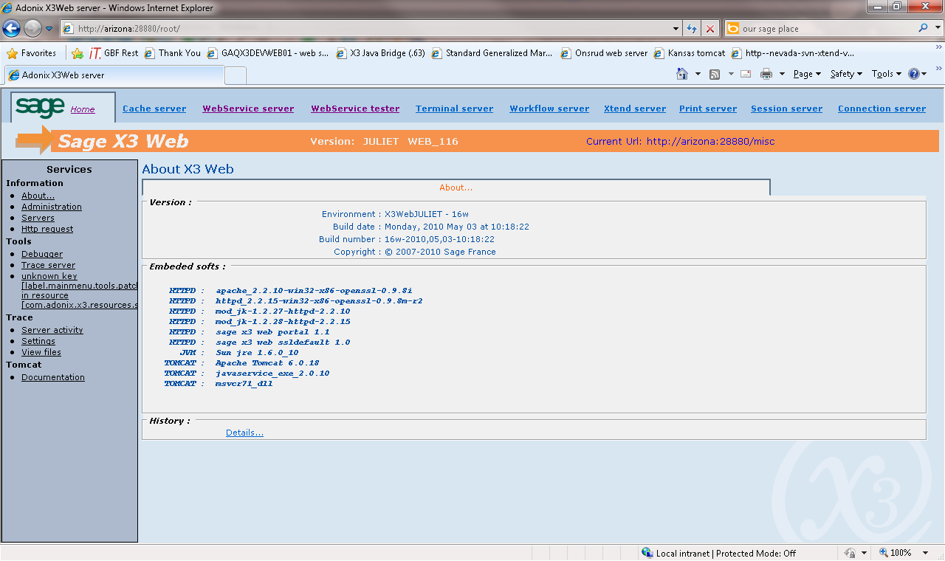

If everything has been setup correctly, select the Webservice Tester Option shown as circled above.

WebService Tester
Connect to the X3 system using the pool configuration information. This is similar to logging on with an X3 client but a port is not required, as the port has been defined in the Pool Configuration information.

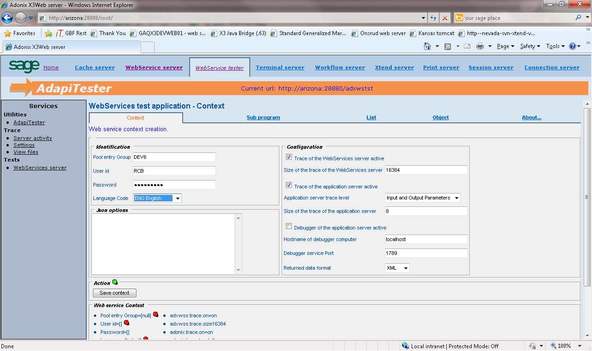

Select the Save Context button when complete.

Test the SALESORDER Web Service

In the X3V6_XA41_webservices document there is an xml document that contains the information for loading a sales order. Similar to a sales order being processed through the X3 client, not all data is required to process an order into X3. Many fields are defaulted.

Access the web service tester and then objects and the object type is SALESORDER.

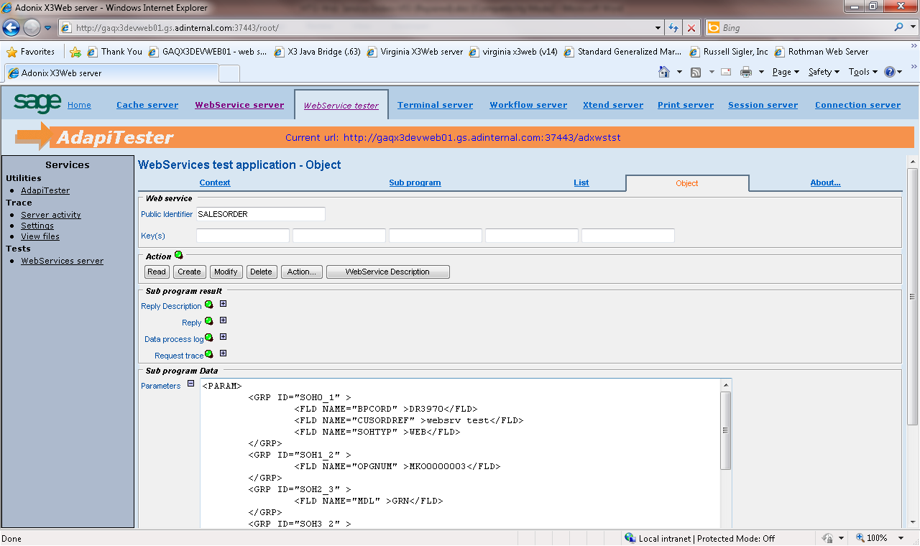
This is data from X3V6_webservice document

Sales Order Results Page
If all has gone well, the results page will show the detail of the sales order posted, as shown below. If the order not post, check the “Data Process Log” and “Trace” files for additional information on what may have caused the order create to fail.

